# Professional Summary

I'm front end web developer, I have an experience in dealing with programming and modern web technologies, and I have built a lot of projects that have increased my experience and trained a lot, I am a fast learner and always love to develop myself.

# Work Experience

**Assiut**

* Medical Representative at ADCO

03/2010 - 06/2021

**Freelancer**

* Front-end web developer

06/2021 - Up till now

* Completed 6 websites templates using HTML, CSS, JavaScript, Bootstrap, Vue.js
* Completed apps by JavaScript (Memory game, Hangman game, Weather journal, Quizz app, Fetch Github ripos).
* Completed apps by Vue.js (To Do List, Gradient generator).
* Multiple HTML & CSS responsive sections.

# Education

**Faculty of Veterinary Medicine, Assiut University.**

* Bachelor of Veterinary Medical Sciences.

09/2003 - 06/2008

**Online Courses**

* Sololearn HTML online course.
* Sololearn CSS online course.
* Sololearn JavaScript online course.

01/2019 - up till now

* Udacity Front End Web Development Challenger Grade Nanodegree.

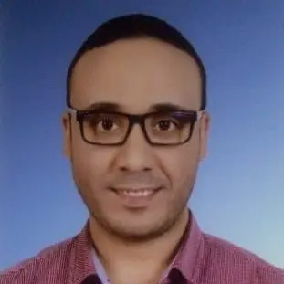

Mahmoud Galal

Contact

**Address**

Egypt, Assiut

**Phone**

02-01020242590

**Email**

[mahmoudegh8@gmail.com](mailto:mahmoudegh8@gmail.com)

**Linkedin** [https://www.linkedin.com/in/dr-](http://www.linkedin.com/in/dr-) mahmoud-galal-313542212/

**Github**

https://github.com/mahmoudegh

**My Portfolio** https://mahmoudegh.github.io/My- Portfolio-Site

Additional Skills

* HTML
* CSS
* JavaScript
* Bootstrap
* Vue.js
* WordPress
* Udacity Front End Web Development Professional Grade Nanodegree.

# References

- My previous works

-----------------------

https://mahmoudegh.github.io/My-Portfolio-Site/#work

-My Certificates

------------------

https://mahmoudegh.github.io/My-Portfolio-Site/#elements